PL/SQL Triggers

CREATE TABLE main (
id NUMBER PRIMARY KEY,
name VARCHAR2(50),
salary NUMBER(10,2)
);

INSERT INTO main VALUES (101, 'John', 30000);
INSERT INTO main VALUES (102, 'David', 40000);
INSERT INTO main VALUES (103, 'Robert', 50000);

COMMIT;

CREATE TABLE backup (
id NUMBER,
salary NUMBER(10,2)
);

create or replace trigger T1
before delete on main
for each row
begin
insert into backup values (:old.id, :old.salary);
end;
/

Select * from main;
delete from main where id = 101;
COMMIT;

Select * from backup;
Select * from main;
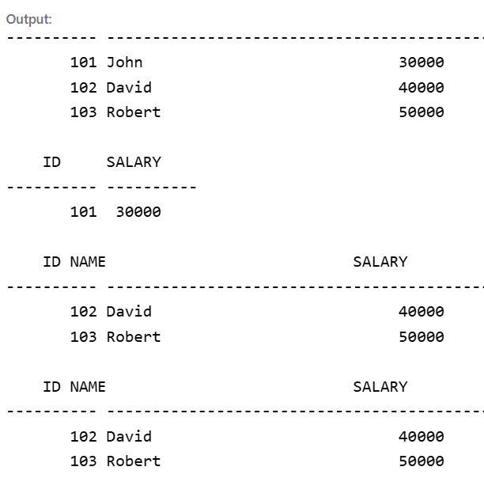

PL/SQL Cursor

CREATE TABLE main (
id NUMBER PRIMARY KEY,
name VARCHAR2(50),
salary NUMBER(10,2)
);

INSERT INTO main VALUES (101, 'John', 30000);
INSERT INTO main VALUES (102, 'David', 40000);
INSERT INTO main VALUES (103, 'Robert', 50000);

COMMIT;

Select * from main;

BEGIN
UPDATE main
SET salary = salary + 5000
WHERE id = 102;

IF SQL%FOUND THEN
DBMS_OUTPUT.PUT_LINE('Record Updated Successfully.');
DBMS_OUTPUT.PUT_LINE('Rows Updated = ' || SQL%ROWCOUNT);
ELSE
DBMS_OUTPUT.PUT_LINE('Record Not Found.');
END IF;

COMMIT;
END;
/

Select * from main;

